**Getting HDF Data from EarthData Tool**

Example get Land Surface Temperature for a specific map and time.

1. Go to:

<https://search.earthdata.nasa.gov/search?m=-57.42010599004337!-35.4375!0!1!0!0%2C2&fst0=Land%20Surface&fsm0=Surface%20Thermal%20Properties&fs10=Land%20Surface%20Temperature>

1. Input KMZ/KML file from Fire Maps

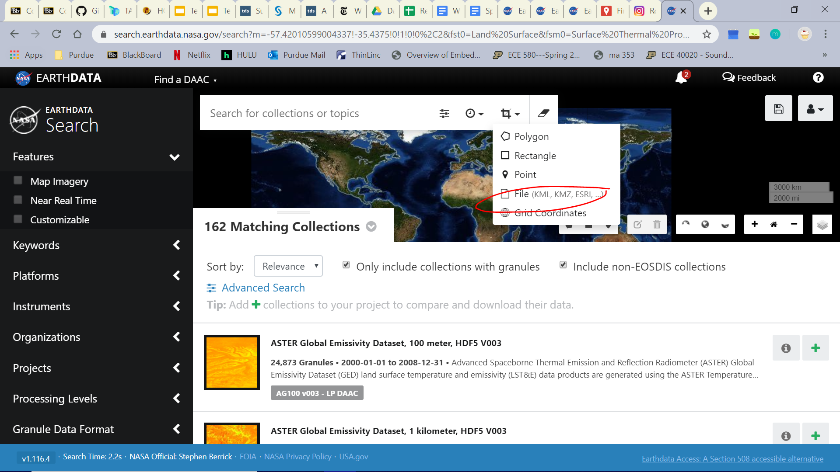

1. Input Date Desired
   1. Fire Duration from [Wildfire List](https://drive.google.com/open?id=1XwHMrNmfh50v8UbSZASCNgLjSOY4cBzX68knFhmIx9k)

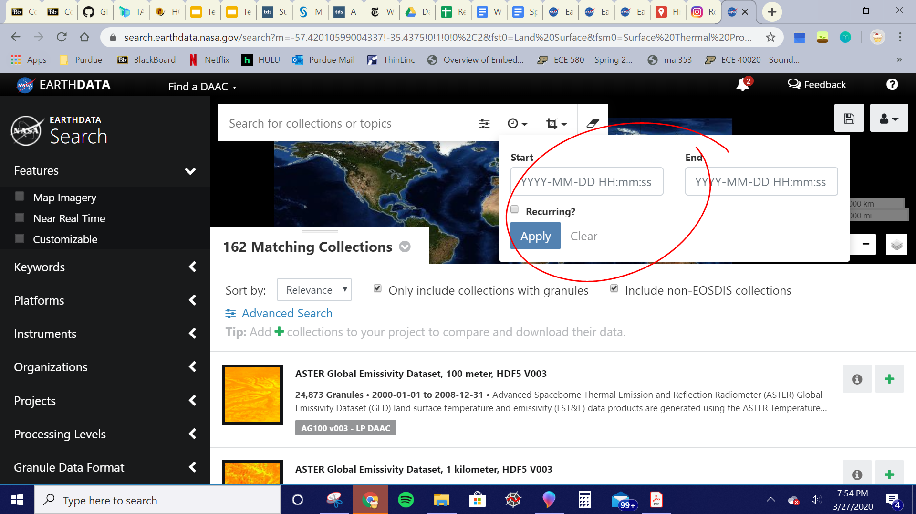

1. You will see it’s highlighted, now filter the modis data you can get so go to **granule data format** make sure **HDF-EOS/HDF4/HDF5** is selected:
   1. **HDF5 is most compatible with python libraries

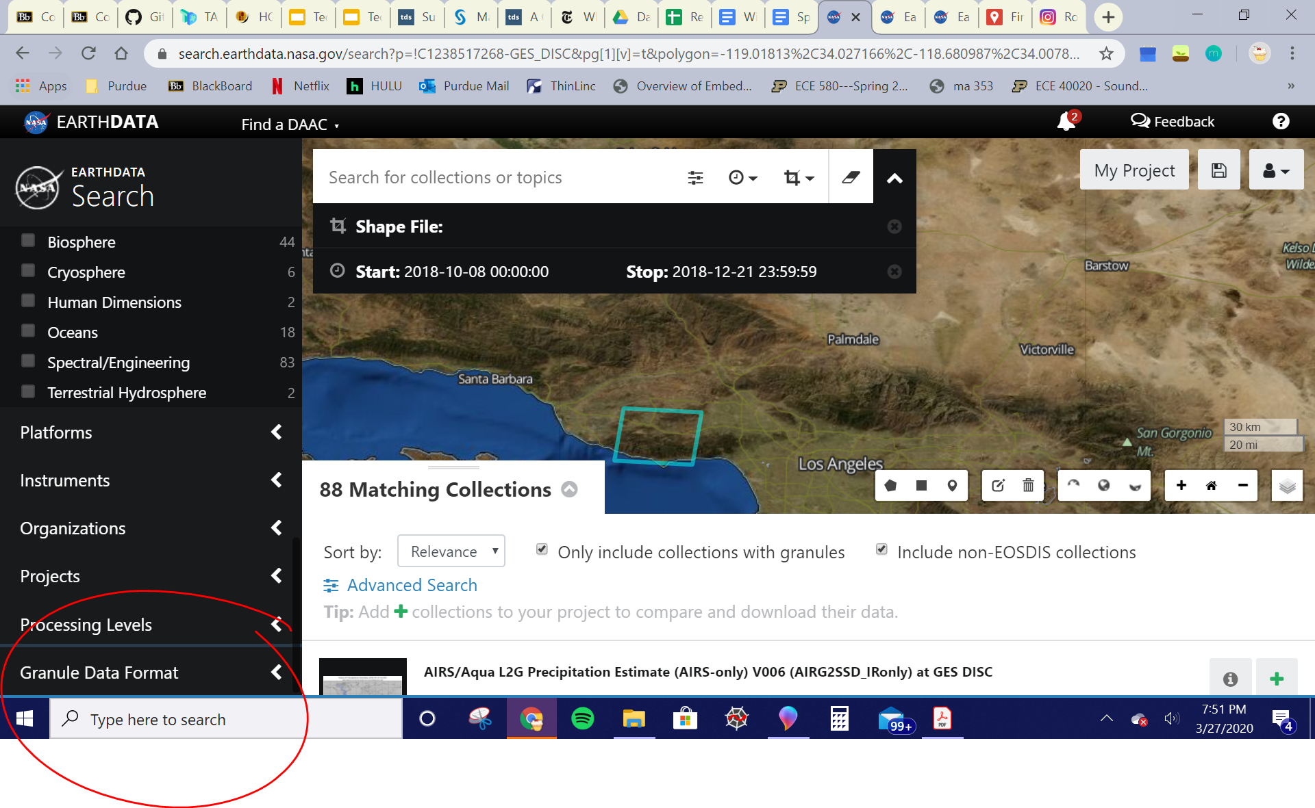

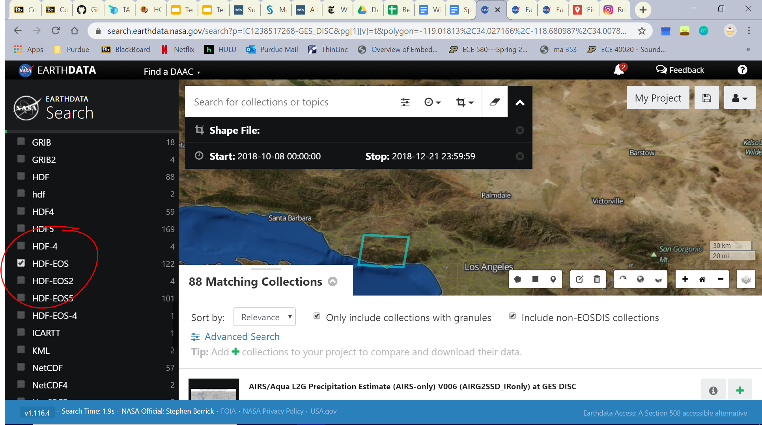

1. Now select keywords for what collection you’re going to get

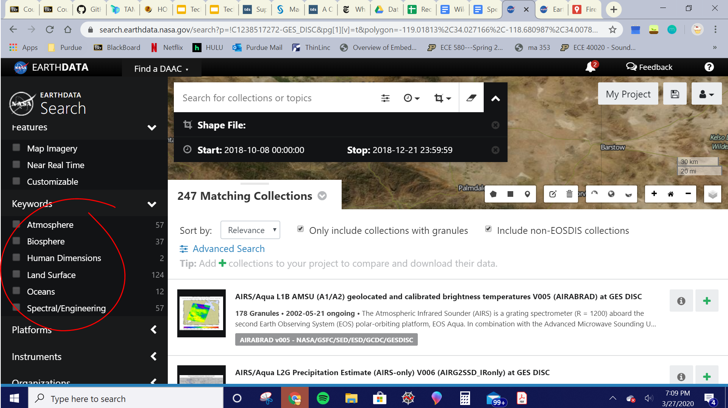

1. Land Surface -> Surface Thermal Properties->Land Surface Temperature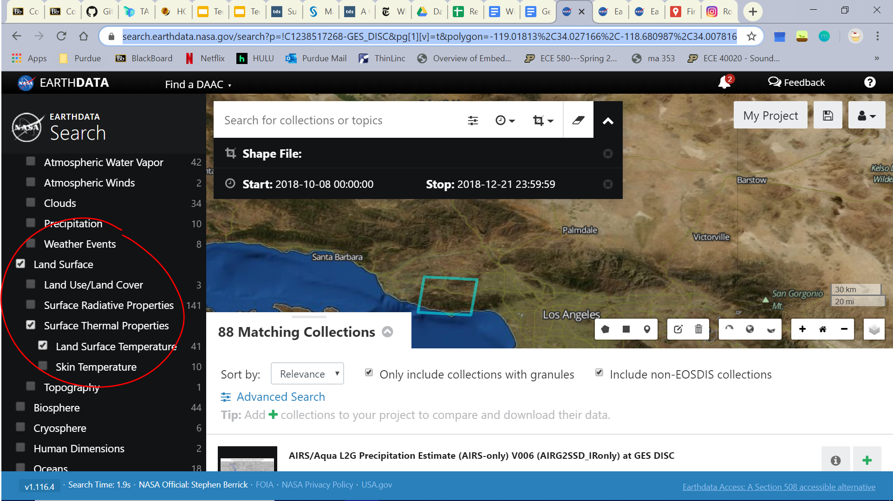
2. Find: **MODIS/Terra Vegetation Indices 16-Day L3 Global 500m SIN Grid V006**

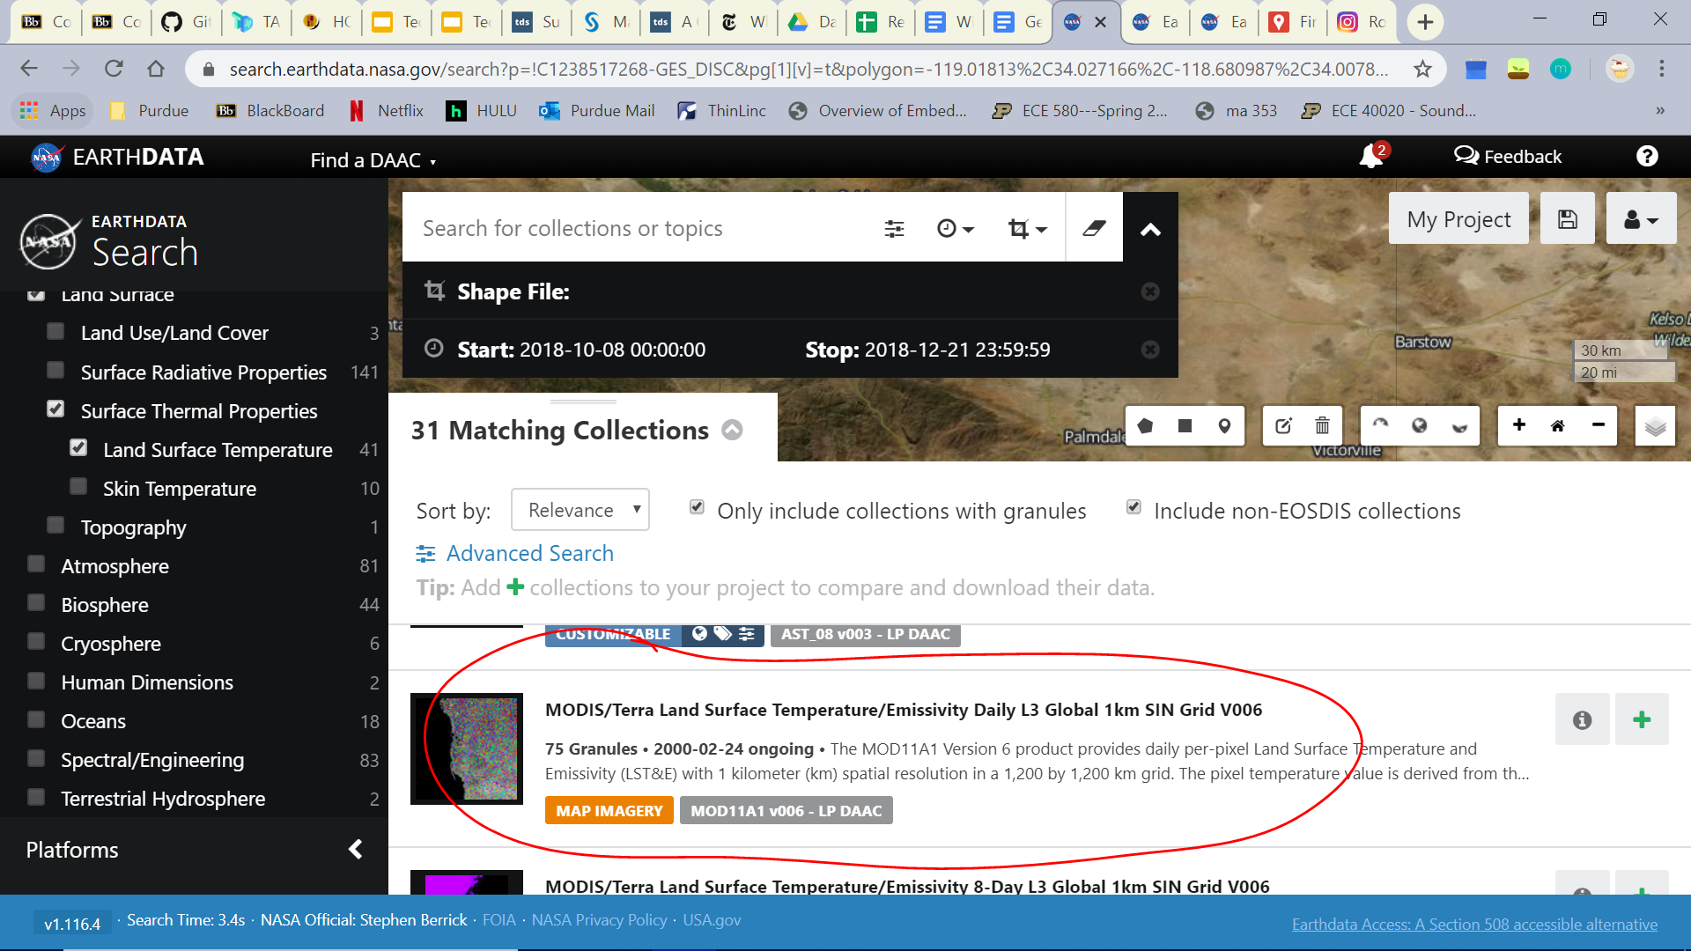

1. Hit it and Download the HDF files

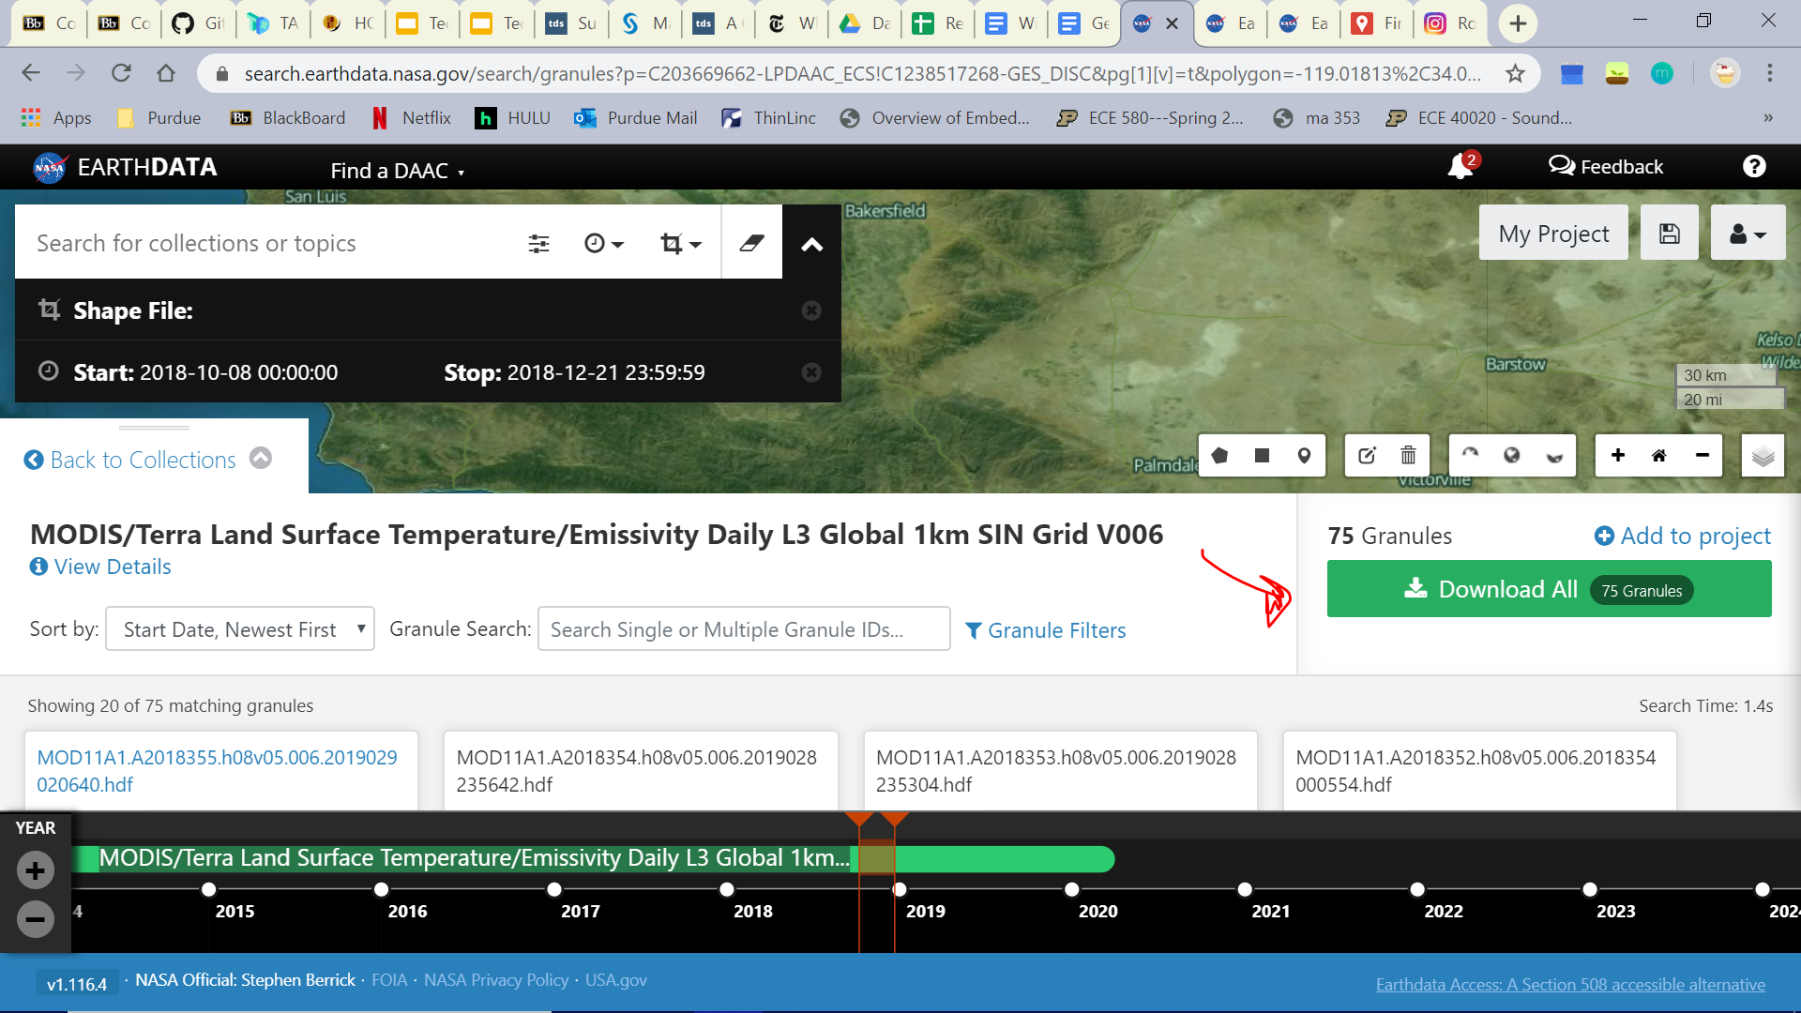

1. Select Download data and then click all the links to download

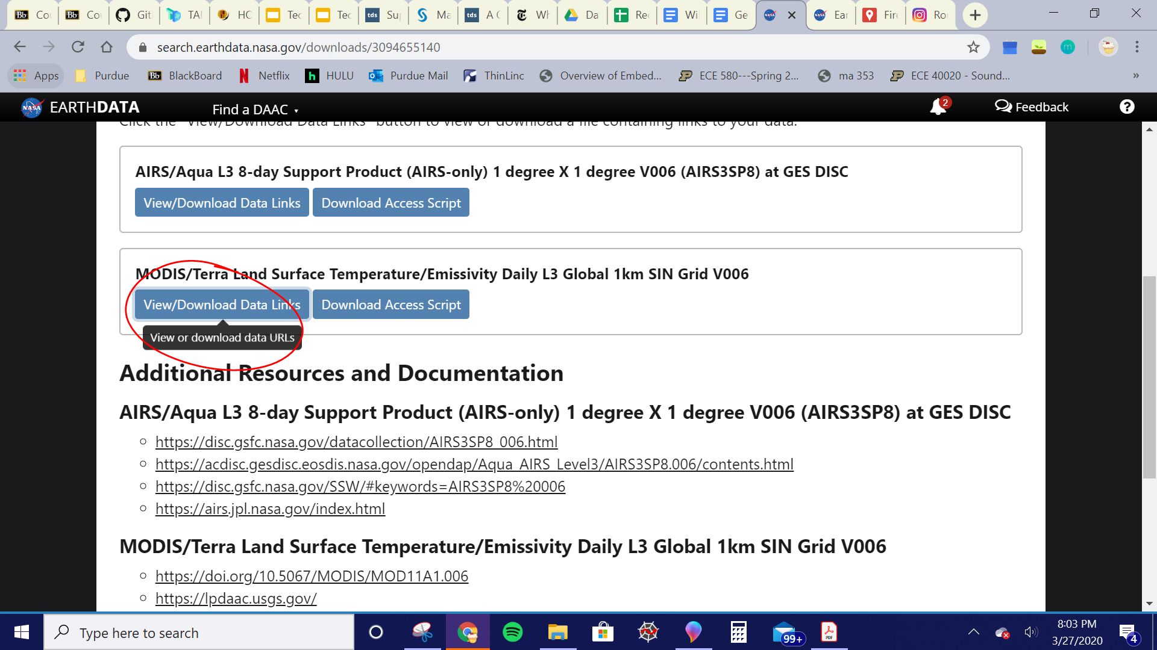

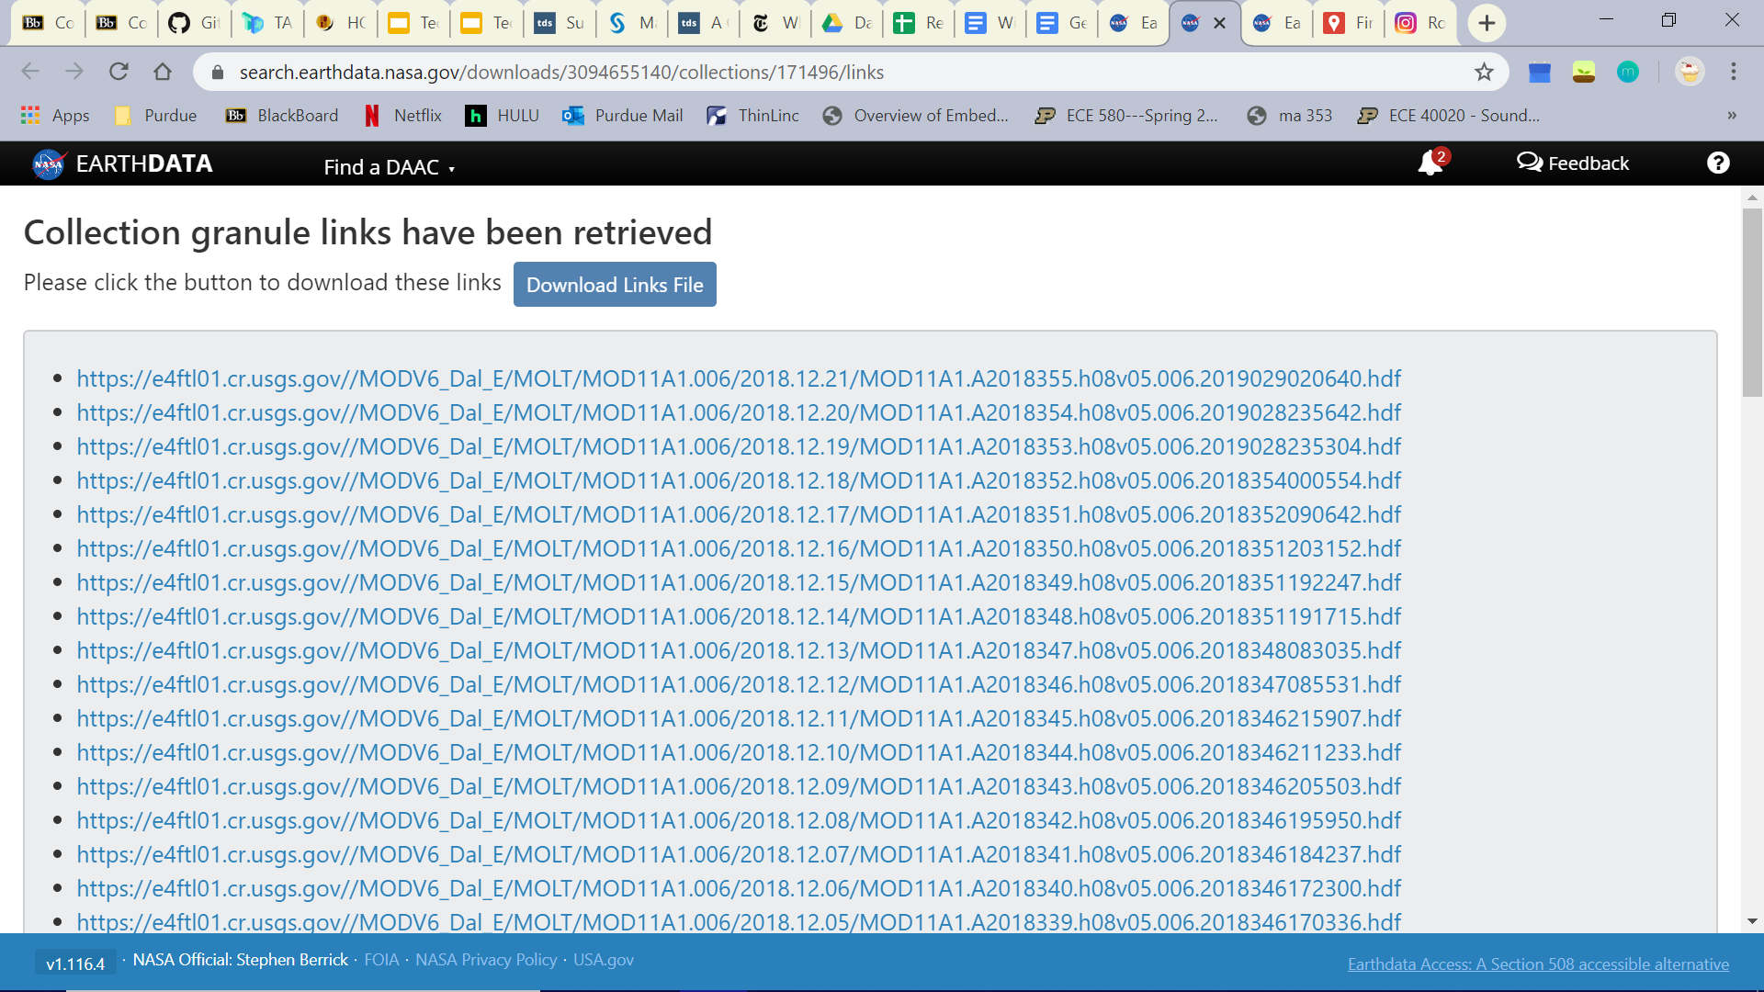

We used these:

Land Surface -> Surface Thermal Properties->Land Surface Temperature:

**MODIS/Terra Land Surface Temperature/Emissivity Daily L3 Global 1km SIN Grid V006**

<https://lpdaac.usgs.gov/products/mod11a1v006/>

[200x200] LST_Day_6km MODIS_Grid_Daily_6km_LST (16-bit unsigned integer)

[200x200] LST_Night_6km MODIS_Grid_Daily_6km_LST (16-bit unsigned integer)

[200x200] Emis_20 MODIS_Grid_Daily_6km_LST (8-bit unsigned integer)

[200x200] Emis_22 MODIS_Grid_Daily_6km_LST (8-bit unsigned integer)

[200x200] Emis_23 MODIS_Grid_Daily_6km_LST (8-bit unsigned integer)

[200x200] Emis_29 MODIS_Grid_Daily_6km_LST (8-bit unsigned integer)

[200x200] Emis_31 MODIS_Grid_Daily_6km_LST (8-bit unsigned integer)

[200x200] Emis_32 MODIS_Grid_Daily_6km_LST (8-bit unsigned integer)

[200x200] LST_Day_6km_Aggregated_from_1km MODIS_Grid_Daily_6km_LST (16-bit unsigned integer)

[200x200] LST_Night_6km_Aggregated_from_1km MODIS_Grid_Daily_6km_LST (16-bit unsigned integer)

[200x200] Emis_20_night MODIS_Grid_Daily_6km_LST (8-bit unsigned integer)

[200x200] Emis_22_night MODIS_Grid_Daily_6km_LST (8-bit unsigned integer)

[200x200] Emis_23_night MODIS_Grid_Daily_6km_LST (8-bit unsigned integer)

[200x200] Emis_29_night MODIS_Grid_Daily_6km_LST (8-bit unsigned integer)

[200x200] Percent_land_in_grid MODIS_Grid_Daily_6km_LST (8-bit unsigned integer)

Biosphere-> Vegetation->Vegetation Index:

**MODIS/Terra Vegetation Indices 16-Day L3 Global 500m SIN Grid V006**

<https://lpdaac.usgs.gov/products/mod13a1v006/>

[2400x2400] 500m 16 days NDVI MODIS_Grid_16DAY_500m_VI (16-bit integer)

[2400x2400] 500m 16 days EVI MODIS_Grid_16DAY_500m_VI (16-bit integer)

[2400x2400] 500m 16 days composite day of the year MODIS_Grid_16DAY_500m_VI (16-bit integer)

Atmosphere->Precipitation:

**AIRS/Aqua L3 8-day Support Product (AIRS-only) 1 degree X 1 degree V006 (AIRS3SP8) at GES DISC**

<https://docserver.gesdisc.eosdis.nasa.gov/repository/Mission/AIRS/3.3_ScienceDataProductDocumentation/3.3.4_ProductGenerationAlgorithms/V6_L3_User_Guide.pdf>

[9x180x360] Dust_Score_A _ct ascending (32-bit floating-point)

[100x180x360] TAirSup_A_ct ascending (32-bit floating-point)

[180x360] IR_Precip_Est_D descending (32-bit floating-point)

[180x360] MWSST_D descending (32-bit floating-point)

[180x360] MODIS_LST_D descending (32-bit floating-point)

Land Surface -> Land Cover:

**MODIS/Terra Vegetation Continuous Fields Yearly L3 Global 250m SIN Grid V006**

Understand the layer: <https://lpdaac.usgs.gov/products/mod44bv006/>

[4800x4800] Percent_Tree_Cover MOD44B_250m_GRID (8-bit unsigned integer)

[4800x4800] Percent_NonTree_Vegetation MOD44B_250m_GRID (8-bit unsigned integer)

[4800x4800] Percent_NonVegetated MOD44B_250m_GRID (8-bit unsigned integer)

[4800x4800] Percent_Tree_Cover_SD MOD44B_250m_GRID (16-bit unsigned integer)

[4800x4800] Percent_NonVegetated_SD MOD44B_250m_GRID (16-bit unsigned integer)

[4800x4800] Cloud MOD44B_250m_GRID (8-bit unsigned integer)

Human Dimensions -> Environmental Impacts:

**MODIS/Terra+Aqua Direct Broadcast Burned Area Monthly L3 Global 500m SIN Grid V006**

**User’s guide**

<https://lpdaac.usgs.gov/products/mcd64a1v006/>

[2400x2400] Burn Date MOD_Grid_Monthly_500m_DB_BA (16-bit integer)

[2400x2400] First Day MOD_Grid_Monthly_500m_DB_BA (16-bit integer)

[2400x2400] Last Day MOD_Grid_Monthly_500m_DB_BA (16-bit integer)

**Video:** <https://vis.ecowest.org/interactive/wildfires.php#year=2014&f=all&loc=WA&h=1>

Severity:

Relativilized burn rate (RBR): remotesensing

dNBR

NVDI: <https://www.tandfonline.com/doi/abs/10.1080/01431160701281072>

<https://bashtage.github.io/linearmodels/devel/panel/examples/examples.html#Covariance-options>

<https://towardsdatascience.com/understanding-panel-data-regression-c24cd6c5151e>

<https://www.statsmodels.org/stable/examples/notebooks/generated/autoregressions.html>

<https://medium.com/pew-research-center-decoded/using-fixed-and-random-effects-models-for-panel-data-in-python-a795865736ab>